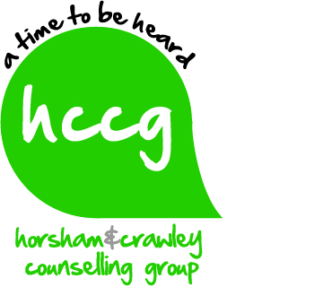
Information for Students seeking Clinical Placements with us
Who are we and what is our client base?
Horsham & Crawley Counselling Group CIC is committed to providing affordable counselling to adults, children and young people in Horsham, Crawley & the surrounding areas. We are a team of experienced qualified counsellors and students who offer day and evening appointments to our client base. As an organisation we abide by the BACP Ethical Framework for Good Practice in Counselling.
We practice in comfortable counselling rooms in Alphacom House in Oakhill Road in Horsham - the building belongs to YMCA Downs Link Group. (YMCA DLG).
The majority of our counsellors’ work on a voluntary basis; offering a commitment to give the minimum of 2 hours free counselling per week to support our work. We operate a sliding scale fee structure to our clients based on their income. Our clients self-refer or are referred in by their healthcare professionals. We work open ended or on a time limited basis, dependent on clients’ needs.
How do we support you as a student counsellor?
As a student counsellor you would receive from us
- Suitably assessed clients for you to work with on a timely basis to help you gain your hours
- Free fortnightly supervision with an appropriately qualified supervisor at Alphacom House
- Free insurance cover whilst you volunteer for the Group
- Induction processes and support from the Clinical Placement Manager
- Involvement in team meetings and CPD opportunities
- The opportunity to practice with a wide range of presenting issues
- The opportunity to engage with a motivated, friendly and experienced counselling team who are dedicated to continuing to offer support to local residents
- We will seek an Enhanced DRB check for you
What we expect from you?
- The ability to see two to three clients a week voluntarily according to your availability
- Evidence of student membership of the BACP or similar professional organisation
- A commitment to support our mission and practice in a way that reflects the ethos of our Group

Before applying what else might I need to think about in relation to my placement?

- We are a community based organisation and a lot of our clients work and attend in the evenings so to give yourself the best chance of getting the experience and clinical hours you need it helps to be available for evening work.
- Our supervision runs fortnightly and we expect you to be able to make arrangements wherever possible to fit in with our supervision timetable.
- If you are travelling some distance to get to us think about making allowances for journey times and the costs involved and be realistic about your availability.
How can you apply?
- Please make initial contact with us by email – we will then invite you to download and complete an application form.

Feb 2015

