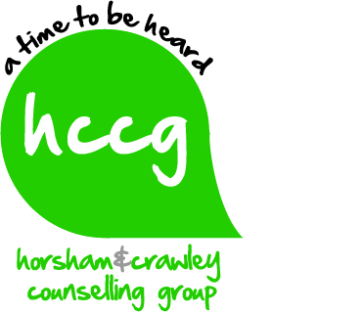
Information for Qualified Counsellors seeking to practice with us
Who are we and what is our client base?
Horsham & Crawley Counselling Group Community Interest Company (CIC) is committed to providing affordable counselling to adults, children and young people in Horsham, Crawley & the surrounding areas. We are a team of experienced qualified counsellors and students who offer day and evening appointments to our client base. As an organisation we abide by the BACP Ethical Framework for Good Practice in Counselling.
We practice in comfortable counselling rooms in Alphacom House in Oakhill Road in Horsham - the building belongs to YMCA Downs Link Group. (YMCA DLG).
The majority of our counsellors’ work on a voluntary basis; offering a commitment to give the minimum of 2 hours free counselling per week to support our work. Some counsellors receive hourly payments for EAP and full fee client work on a consultancy basis but the majority of our work currently is voluntary.
- We operate a sliding scale fee structure to our clients based on their income. Our clients self-refer or are referred in by their healthcare professionals. We work open ended or on a time limited basis, dependent on clients’ needs.
- We also hold a number of local EAP contracts
What do we offer you as a counsellor?
As a qualified counsellor you would receive from us
- Free fortnightly supervision with an appropriately qualified supervisor at Alphacom House
- Free insurance cover whilst you volunteer for the Group
- Induction processes and support from the Management Team
- Involvement in team meetings and CPD opportunities
- The opportunity to practice with a wide range of presenting issues and age groups with scope to expand your practice with us
- The opportunity to engage with a motivated, friendly and experienced counselling team who are dedicated to continuing to offer support to local residents

What we expect from you?
- The ability to see two to three clients a week voluntarily according to your availability
- Evidence of membership of the BACP or similar professional organisation
- Evidence wherever possible of an Enhanced DBS check less than 3 years old.
- A commitment to support our mission and practice in a way that reflects the ethos of our Group

What are the future plans for the Group?

- We have become a Community Interest Company (C.I.C.) in order to create an appropriate and formal business structure in which we can grow and diversify the client work the Group carries out
- Counsellors who join the Group will be asked to become subscribers to our CIC. We will explain this in more depth to you if you apply to join us.
- To acquire new premises from which to operate
- To increase our capacity and to expand our operations with local EAP counselling programmes and providers
How can you apply?
- Please make initial contact with us by email – we will then invite you to download and complete an application form.

Feb 2015

